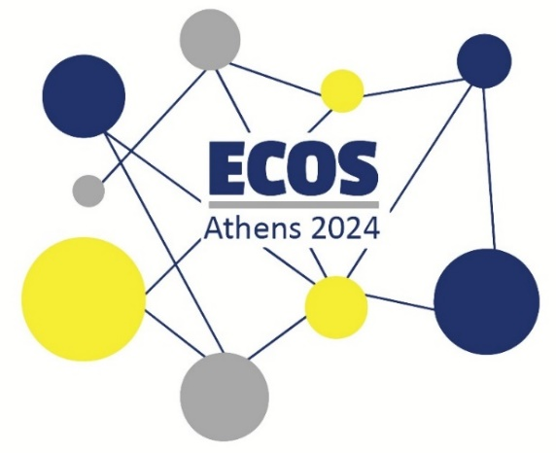
European Conference of Speech-to-Text Interpreters
ECOS ATHENS 2024 – CONFERENCE WORKSHOPS
(ATHENS TIME ZONE)

Saturday, 20th of July 2024 at 11.00

1a. Pre-conference Workshop on Accessibility (English - Online)
Register here!

Monday, 22nd of July 2024 at 18.30

1b. Pre-conference Workshop on Accessibility (Greek – Online)
Register here!

What is the workshop about?
The aim of this workshop is to offer an introduction to Accessibility, Audiovisual Translation and Access Services. The workshop will be interactive and allow an open discussion with questions about accessibility and access services. This workshop will also focus on the characteristics of each service from the professionals’ point of view as well as quality parameters that the audience should be aware of.

Do I need to have prior knowledge on the topic?
No prior knowledge on the topic is required in order to attend this workshop.

What is the mode of delivery of this workshop?
This workshop is delivered online via Zoom. All registered participants can access it through a link that we will email to the email address they have used to register to the conference. If you have not received the link yet, please email us at prosvasisresearch@gmail.com

Do I need to own/bring equipment in order to attend?
You just need a device with a good and steady internet connection. The workshop will be delivered on Zoom. The Greek workshop will be delivered with Greek Sign Language, so you may want to use a device with space for two pinned windows on Zoom.

How much does the workshop cost?
The workshop is offered for free by ATLAS E.P. and PROSVASIS – Universal Access Research and Innovation Lab.

Who will deliver this workshop?
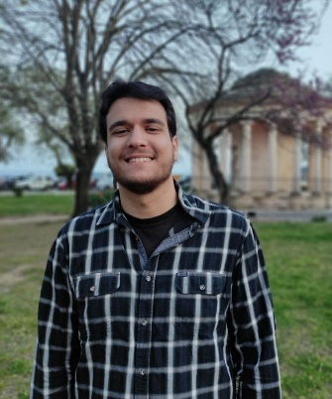
Emmanouela Patiniotaki and Ilias Katsigiannis will share their knowledge on the topic. Emmanouela has worked in this area for 15 years. She is a professional audiovisual translator and access service provider and she has also done a lot of research on Accessibility through Audiovisual Translation. She holds a PhD, currently working on her post-doc on Accessibility and she is an academic in the field. Ilias has completed a Masters course in Accessibility to Media, Arts and Culture and is currently working on many accessibility projects for ATLAS E.P., including access services for the theater and the cinema.
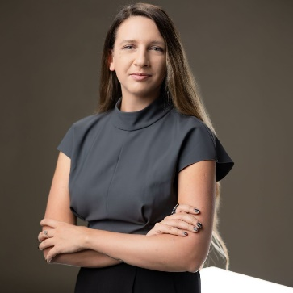

Friday, 26th of July 2024 at 16.30
2. Workshop: STTI basic typing skills for beginners 16.30-18.30
Register here!

What is the workshop about?
The aim of this workshop is to offer basic typing skills for people who are just starting with STTI and want to see how and where to start with typing. The tutor will share his experience on how to create basic word lists and organize your tools in order to get started with typing for STTI.

Do I need to have prior knowledge on the topic?
Basic knowledge on typing will help you attend the workshop more smoothly. So using Microsoft Word for example is useful.

What is the mode of delivery of this workshop?
This workshop is delivered at the conference hall.

Do I need to own/bring equipment in order to attend?
Yes, you need to bring your own laptop in order to attend more easily. If you don’t have a laptop, we will make sure we share one of ours with you, no problem!

How much does the workshop cost?
The workshop costs 30 euro.

Who will deliver this workshop?
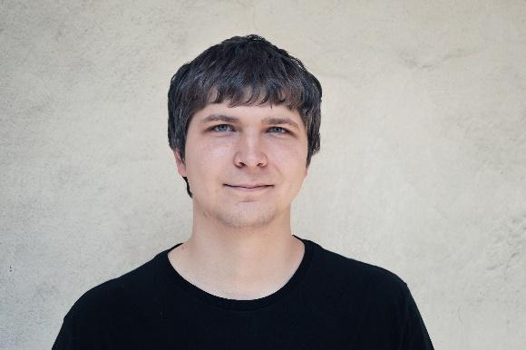
Tomáš Portych will deliver this workshop!
He has been working as a Speech-to-Text Interpreter for social services in Czech Republic since 2012 via QWERTZ/Y method. He has been teaching typing with the all-ten-fingers method and theory of STTI work at Charles University. The right person for the task!

Saturday, 27th of July 2024 at 16.30
3. Workshop: Interlingual STTI for professionals 16.30-18.30
Register here!

What is the workshop about?
This is what the tutors say: “Our team of two conference and speech-to-text interpreters has gathered a lot of experience in interlingual STTI (Mostly German and English) in different settings - online, hybrid and on site. In the community we have heard more and more often that colleagues would be interested to try it, before accepting a job, but did not get the chance yet.
This is why we want to give anyone interested the opportunity to practice in the setting of a practical workshop.
We will give a short introduction, talk about our experiences, tips and tricks and then give the participants the possibility to try it themselves. We will provide the speeches in any European language for interpreting into English and will have feedback rounds to talk about the experience and elaborate on problems, strategies etc. together.
Participants will have to bring their own laptop with a speech-to-text software.

Do I need to have prior knowledge on the topic?
Yes, you need to be a professional in the field in order to attend this workshop.

What is the mode of delivery of this workshop?
This workshop is delivered at the conference hall.

Do I need to own/bring equipment in order to attend?
It would be great if you brought your laptop with any speech-to-text software you own, as well as a headset and, if possible, also a silencer mask.

How much does the workshop cost?
The workshop costs 40 euro.

Who will deliver this workshop?
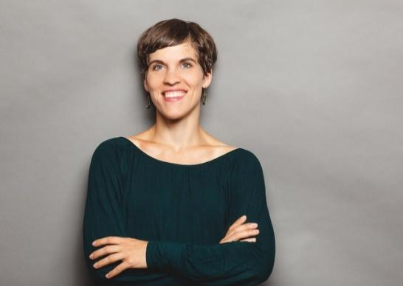

Nina Cisneros Arcos is a Conference and Speech-to-text Interpreter for German, English, French and Spanish, founder and CEO of the Orelon GmbH, providing accessible and inclusive communication. She has many years of experience in interpreting in different settings and languages and offers workshops and training in inter- and intralingual STTI.

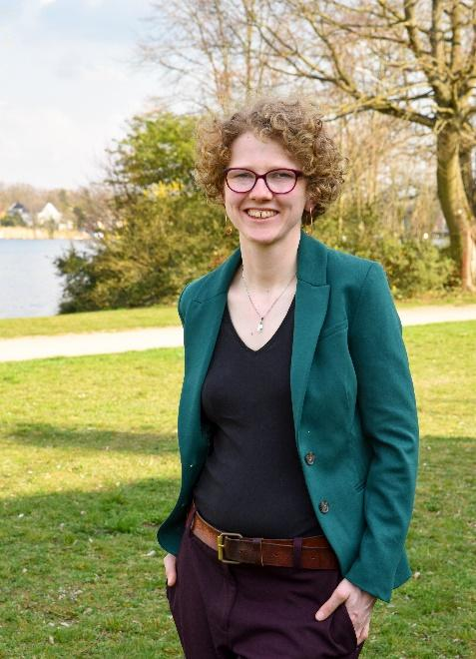

Luisa Donachie-Bach is a freelance M.A. Conference Interpreter ("Greenterpreter") based in Berlin, working with German, English and French and is certified as an STTI. In this area, she also works as a freelancer, mostly in event settings, intralingually and interlingually. For many years now, she has been regularly working for the public broadcasting TV channel for Berlin and Brandenburg as a Live Subtitler of the news and other TV formats as well as a subtitler in general.

We hope you enjoy the ECOS Athens 2024 Workshops!

