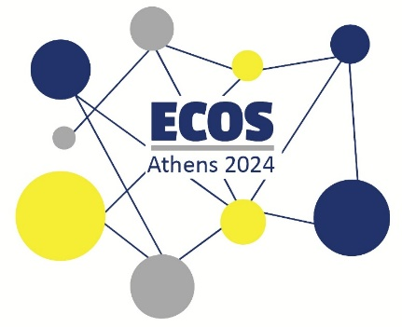
ECOS ATHENS 2024 ● REGISTRATION
STEP-BY-STEP GUIDE

Step 1: Go to the website
- Go to the website of Prosvasis Research & Innovation Lab for Technology, Society and the Arts by visiting the following link: https://www.prosvasisresearch.com/.

- When you are at the homepage, click on “ECOS 2024”, and then “Participation”.
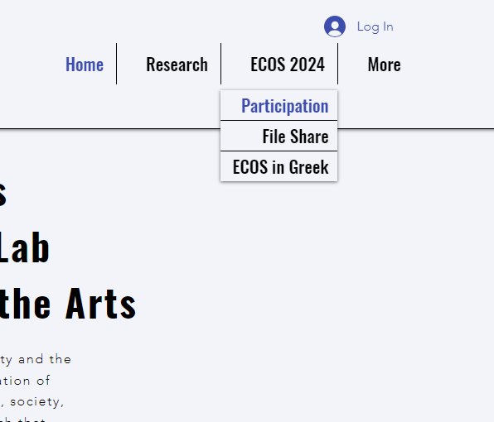

- Here you can find all the information about the ticket fees, the workshops and the social programme of the conference.

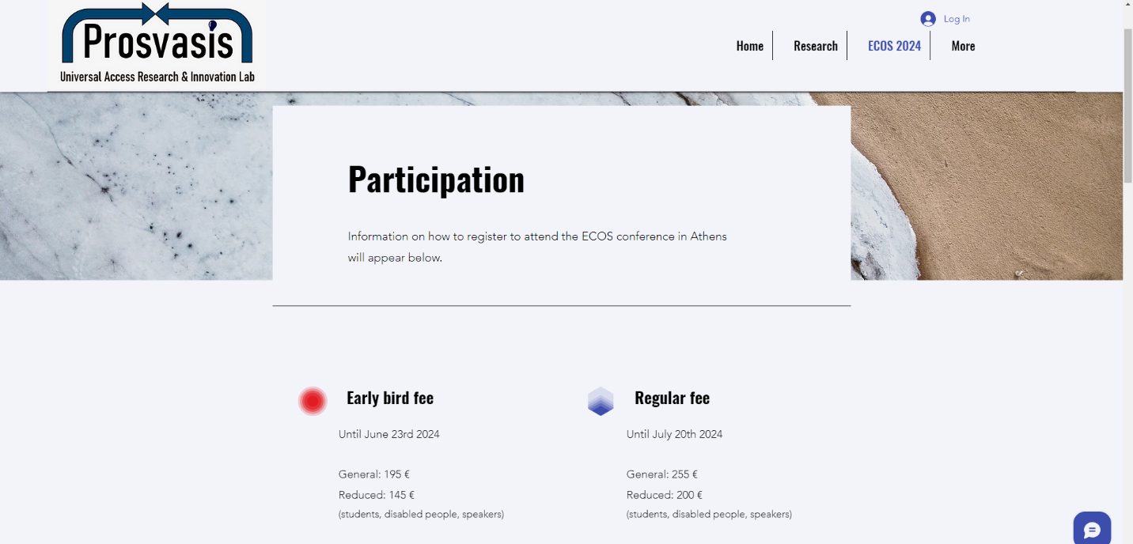

- At the bottom of the Participation page, click on “Register Now”.

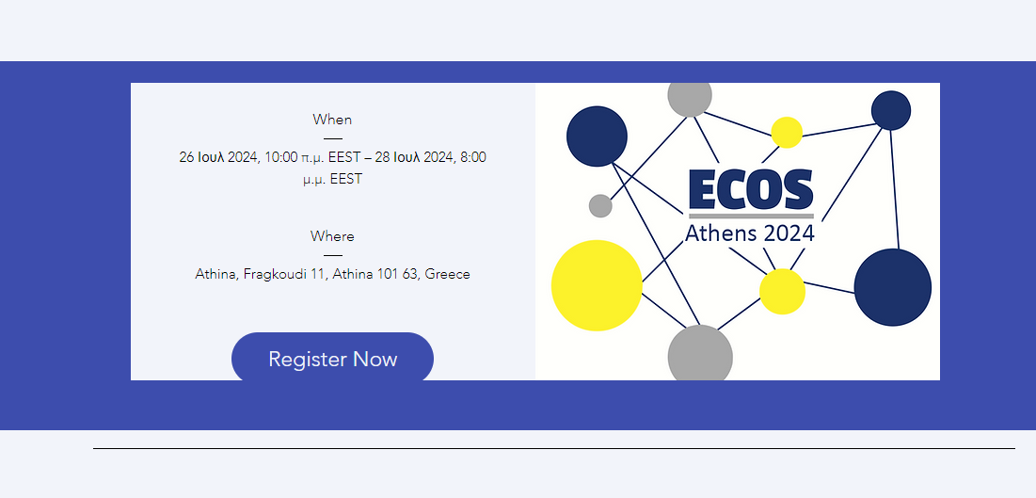

- On this page, you can find all the information about the time and location of the conference and you can also buy your ticket.
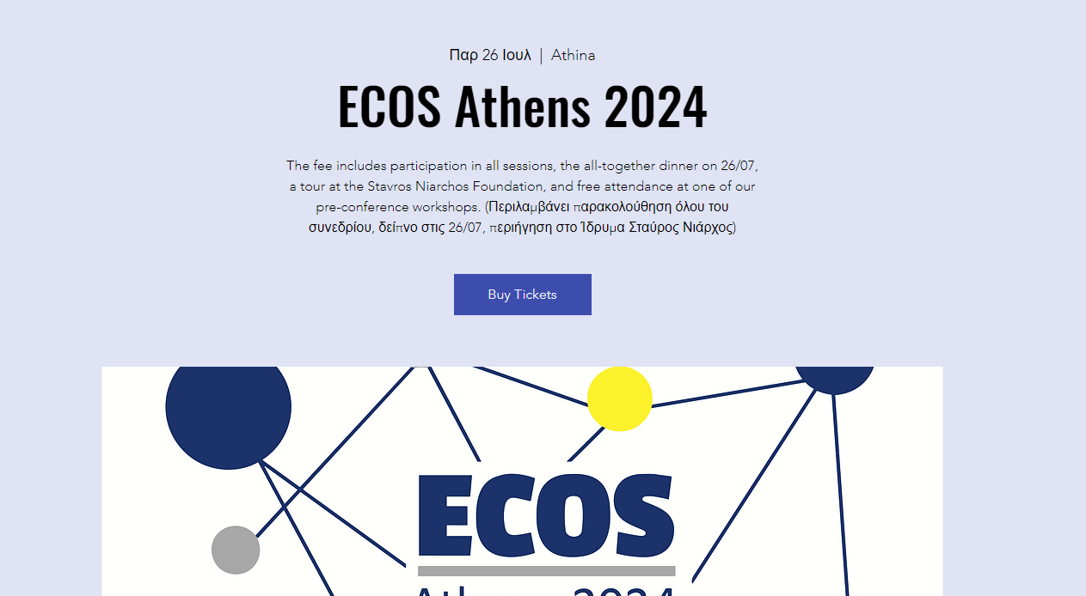

Step 2: Select your Ticket
A ticket for the conference includes participation in all sessions, the all-together dinner on the 26th of July, a tour at the Stavros Niarchos Foundation, and free attendance at one of our pre-conference workshops.
- Choose your ticket at the bottom of the page:
  - Early bird - General: 195€ (until June 23rd)
  - Early bird - Reduced: 145€ for speakers, students and disabled people (until June 23rd)
  - General: 255€
  - Reduced: 200€ for speakers, students and disabled people
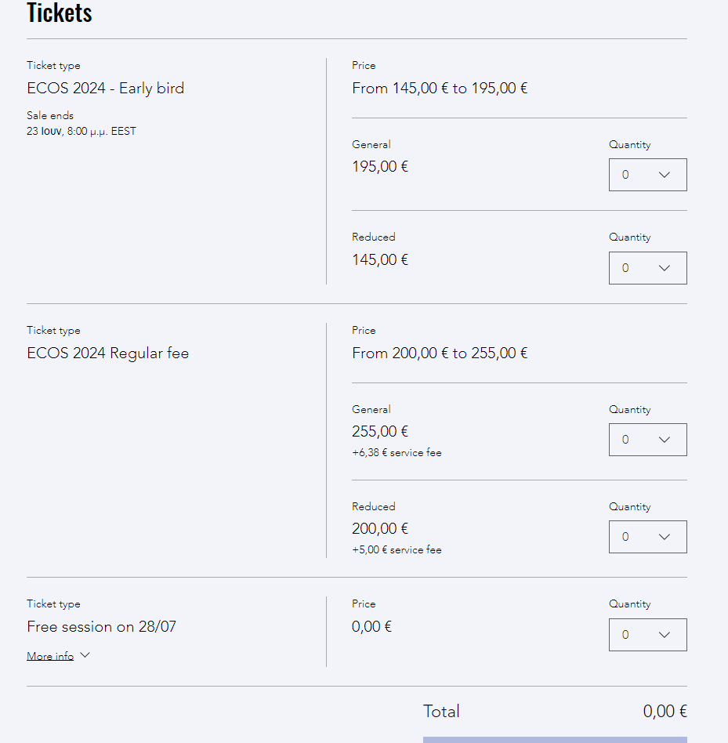

- Do not forget to also register for the free session “Bring STTI to least used languages” on the 28th of July, if you are planning to attend it.

- Once you have selected your ticket, proceed to “Checkout”.

Step 3: Add your details
- Provide your personal details, including your name and email address.

- Do not forget to pick the accessibility service you may need in order to attend the conference smoothly.

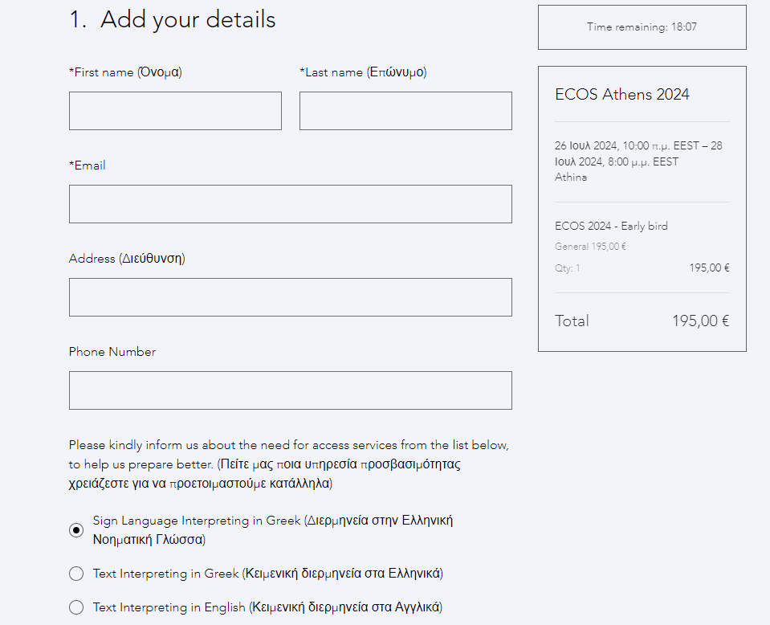

- Review your registration details carefully to ensure everything is accurate.

- Click on “Continue”.

Step 4: Complete the payment
- Complete the bank transfer in the following bank details:
  - IBAN: GR34 0172 1080 0051 0811 2231 378
  - BIC: PIRBGRAA
  - Account name: ΠΡΟΣΒΑΣΙΣ-ΕΡΓΑΣΤΗΡΙ ΚΑΙΝΟΤΟΜΙΑΣ ΚΑΘΟΛΙΚΗΣ ΠΡΟΣΒΑΣΙΜΟΤΗΤΑΣ (PROSVASIS-UNIVERSAL ACCESS INNOVATION LAB)
  - In case you pay from a bank account that is not under your name, make sure to include in the transfer details your full name or contact us in order to let us know.
- Make sure to not miss this step, otherwise your registration will not be valid.

- Click on “Place Order”.

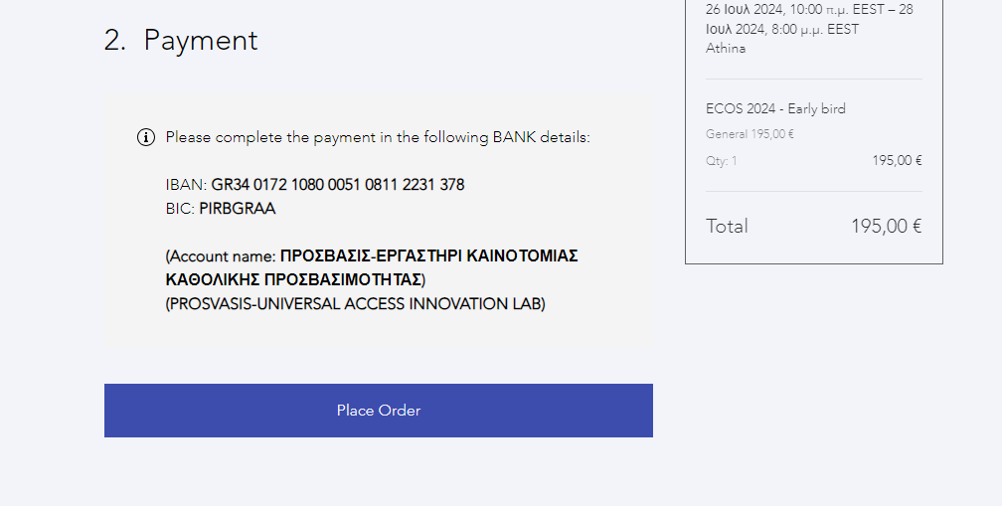

Step 5: You are ready!
- Click on “Download Ticket” to get your ticket for ECOS 2024.

- An email with your ticket has also been sent to your email address. Keep this email for your records, as you may need to refer to it later.

- The organisers will also contact you with an Official Invoice/Receipt in due time, once the payment is completed.

If you notice any errors or discrepancies in your registration details or if you have any questions, you may contact us at prosvasisresearch@gmail.com.

